**Vegonomics**

- Empowering seamless bill division.

Sumeet Deshpande

16/06/2023

(TASK-0)

“Unlocking the flavors of unity by revolutionizing the dining experience.”

# Abstract

The segregation of bills between vegetarian and non-vegetarian dishes in restaurants can often be a tedious and error-prone task. To simplify this process, we introduce an innovative solution called "Vegonomics." Leveraging the power of AI technology, Vegonomics provides an efficient and accurate method to split bills based on the consumption of veg and non-veg items. By analyzing the menu, identifying dish ingredients, and taking into account customer preferences, Vegonomics automates the bill division process, ensuring fairness and convenience for all diners. With Vegonomics, restaurant-goers can enjoy a seamless dining experience without the hassle of manual bill calculations, fostering harmony and satisfaction among diverse dietary choices.

# Introduction:-

In the vibrant world of culinary delights, restaurants have become hubs of gastronomic exploration, catering to diverse dietary preferences. In the bustling world of dining out, restaurants cater to a wide range of dietary preferences, including vegetarian and non-vegetarian choices. However, when it comes to settling the bill, dividing expenses accurately between these two categories can become a challenging task. To alleviate this common predicament, we present "Vegonomics," an innovative solution that harnesses the power of AI technology to seamlessly segregate bills based on the consumption of veg and non-veg dishes. By automating the bill division process, Vegonomics aims to simplify and streamline the dining experience, ensuring fairness and convenience for all patrons.

However, amidst the delightful chaos of savoring flavors and indulging in delectable dishes, the age-old challenge of dividing bills between vegetarian and non-vegetarian options often arises. To address this common dilemma, we present "Vegonomics," an innovative AI-powered solution that revolutionizes the way restaurant bills are split.

Vegonomics emerges as a beacon of convenience and fairness in the realm of dining experiences. By seamlessly and accurately segregating bills between veg and non-veg items, it eliminates the need for manual calculations and potential errors. With Vegonomics, the days of painstakingly scrutinizing receipts, negotiating expenses, and resolving bill disputes are left behind.

This ground-breaking solution harnesses the power of artificial intelligence to analyze menu data, dish ingredients, and customer preferences with remarkable precision. By leveraging advanced algorithms, Vegonomics effortlessly identifies and categorizes each dish, providing an equitable distribution of expenses for all diners.

In this report, we embark on a journey into the depths of Vegonomics, exploring its remarkable functionality and the myriad benefits it brings to the table. From ensuring transparency and accuracy to fostering harmony and satisfaction, Vegonomics emerges as a game-changer in the realm of dining economics. Join us as we delve into the intricacies of this innovative solution, uncovering how Vegonomics transforms the bill-splitting experience, one restaurant at a time.

# Problem statement:-

Diners often encounter challenges when attempting to divide expenses accurately, leading to confusion, disagreements, and even strained relationships among friends or colleagues. The reliance on manual calculations and subjective judgment to allocate costs adds complexity to an already complex dining experience. Furthermore, the restaurant staff is burdened with the responsibility of resolving bill-splitting disputes, which consumes time and resources that could be better utilized in providing quality service. Inefficient bill-splitting processes not only disrupt the dining flow but also impact overall customer satisfaction and the restaurant's reputation.

The absence of a robust and automated system specifically designed to handle the segregation of veg and non-veg bills exacerbates these issues. As a result, there is a pressing demand for an innovative solution that leverages technology, such as AI, to accurately and fairly divide expenses between vegetarian and non-vegetarian items, streamlining the bill-splitting process and enhancing the dining experience for all parties involved. Addressing these challenges with an intelligent and intuitive solution will not only eliminate the complexities associated with bill splitting but also foster harmony and satisfaction among diners, ultimately benefiting both customers and restaurants alike.

# Gauging Customer, Market & Business needs

Since the advent of AI & with the intense research being conducted, there never has been a better decade than the current one to invest & leverage AI to its best & for as many needs as wanted, needed. No matter what field AI is used in, it never ceases to surprise us. Understanding the customer, market, and business needs is crucial for the successful development and implementation of a solution like Vegonomics. Here are some key considerations:

**Customer Needs:**

1. Accuracy and Fairness: Customers desire a bill-splitting solution that accurately segregates expenses between vegetarian and non-vegetarian dishes, ensuring fairness and transparency.

2. Convenience and Efficiency: Customers seek a streamlined process that simplifies the bill-splitting experience, eliminating manual calculations and potential disputes.

3. Personalization: Customers may have specific dietary preferences or restrictions, and they would appreciate a solution that takes individual preferences into account during the bill division process.

**Market Needs:**

1. Industry Standards: The market demands a solution that aligns with industry standards and addresses the prevalent challenges faced by customers and restaurant establishments.

2. Enhanced Dining Experience: Restaurants strive to provide a positive and seamless dining experience for their customers, and a reliable bill-splitting solution can contribute to that goal.

3. Competitive Edge: Restaurants are continuously seeking innovative ways to differentiate themselves from competitors, and adopting a technologically advanced bill-splitting system can serve as a unique selling point.

**Business Needs:**

1. Operational Efficiency: Restaurants aim to optimize their operations, and a time-saving and automated bill-splitting solution can contribute to improved efficiency in managing customer bills.

2. Customer Satisfaction and Retention: Satisfied customers are more likely to return and recommend the restaurant to others. By addressing the bill-splitting challenges, restaurants can enhance customer satisfaction and foster customer loyalty.

3. Cost Management: By implementing a reliable bill-splitting system, restaurants can minimize errors and disputes related to bill division, ultimately leading to improved cost management and reduced overhead.

By aligning the solution with the needs of customers, the market, and the business, Vegonomics can cater to the demands of all stakeholders involved, resulting in a successful and impactful implementation that benefits both customers and restaurants alike.

## Force of AI in the Restaurant Industry:-

Leveraging AI for restaurants can bring numerous benefits and opportunities. Here are some key ways to leverage AI in the restaurant industry:

1. Personalized Recommendations: Utilize AI algorithms to analyze customer preferences, order history, and dining patterns to offer personalized menu recommendations. AI can help suggest dishes based on individual tastes, dietary restrictions, and past orders, enhancing the customer dining experience.

2. Intelligent Menu Engineering: Use AI to analyze sales data, customer feedback, and ingredient costs to optimize menu offerings. AI algorithms can identify popular dishes, identify profitable menu items, and suggest menu modifications to improve overall profitability.

3. Efficient Inventory Management: AI can optimize inventory management by analyzing historical data, current stock levels, and demand patterns. AI-powered systems can automatically generate purchase orders, optimize inventory levels, and minimize waste, leading to cost savings and improved operational efficiency.

4. Streamlined Order Taking and Processing: Implement AI-powered chatbots or voice assistants to handle order taking, answer customer queries, and process orders. This reduces wait times, minimizes errors, and enhances the customer ordering experience.

5. Predictive Maintenance: Utilize AI algorithms to monitor equipment performance and detect anomalies. By analyzing sensor data, AI can predict maintenance needs, prevent equipment breakdowns, and optimize repair schedules, reducing downtime and improving operational efficiency.

6. Demand Forecasting: AI can analyze historical sales data, seasonal trends, weather patterns, and other variables to accurately forecast future demand. This enables restaurants to plan ingredient procurement, staffing, and operational requirements more effectively, avoiding stock-outs or overstock situations.

7. Enhanced Customer Service: AI-powered chatbots or virtual assistants can handle customer inquiries, reservations, and feedback. Natural language processing algorithms enable these AI systems to provide personalized and prompt responses, improving customer satisfaction.

8. Fraud Detection and Security: AI can analyze transactional data to detect suspicious activities, potential fraud, or security breaches. By leveraging machine learning algorithms, restaurants can enhance payment security and protect customer information.

9. Data Analytics and Insights: AI can process and analyze large volumes of data, providing actionable insights and trends. This helps restaurants make data-driven decisions, optimize operations, and identify areas for improvement.

10. Streamlined Staff Scheduling: AI algorithms can analyze historical sales data, customer footfall, and other factors to generate optimized staff schedules. This ensures appropriate staffing levels, reduces labor costs, and improves overall operational efficiency.

By leveraging AI in these areas, restaurants can enhance customer experiences, streamline operations, reduce costs, and gain a competitive edge in the industry. It's important to consider the specific needs and resources of each restaurant while implementing AI solutions to maximize their benefits.

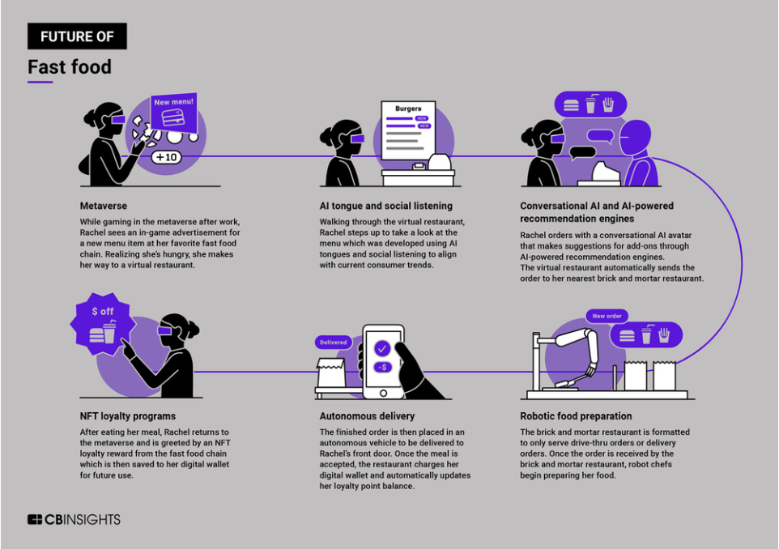

# Target Specifications

Target specifications refer to the specific requirements, criteria, or goals that need to be met or achieved by a product, system, or solution. These specifications are defined based on the desired outcomes and objectives of the project.

In the context of leveraging AI in the restaurant industry, target specifications would encompass the desired characteristics, capabilities, and performance expectations of the AI solution. These specifications may include factors such as accuracy, speed, scalability, integration, user-friendliness, security, adaptability, cost-effectiveness, and customer satisfaction.

By establishing clear target specifications, stakeholders can align their efforts and ensure that the AI solution meets the specific needs and expectations of the restaurant, its customers, and the broader business objectives. These specifications serve as a guide and benchmark for the development, implementation, and evaluation of the AI solution.

# Benchmarking products

Benchmarking Products for AI-based Restaurant Solutions:

1. **Plates:** This app gives everyone in the group a “plate”. Then as you add items to the group, they can be placed on a specific person’s plate or split up among the entire group. The app can handily accommodate large add up to 10 people to each group.

2. **Splid:** Splid allows you to add in all the expenses of a trip and then split it among each person in the group. The app is useful for splitting up non-trip expenses as well. Multiple payees can be added to each group and then an offline PDF or EXCEL can be downloaded for the same.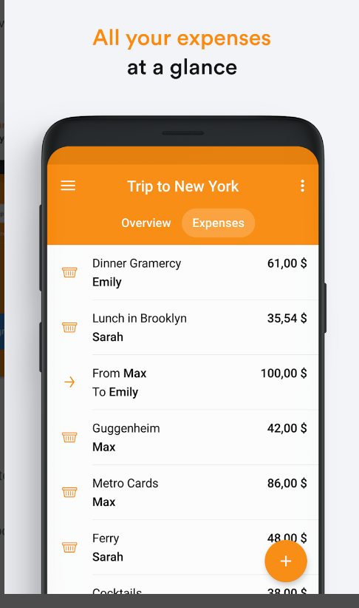

3. **Venmo:** Although not a way to track expenses, Venmo lets you split a bill and pay friends back immediately, but it does require some math on your part.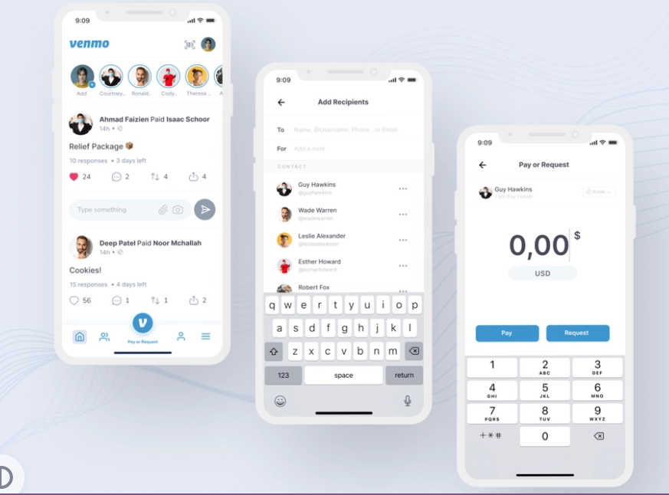

4. **Cash-Up:** It’s a peer-to-peer payment platform, it can be useful for splitting payments. Once you’ve determined how a payment should be split you can send a payment request to each person in the group right through the app.

5. **Splitwise:** Splitwise is a popular expense-sharing platform that can be leveraged by diners to split bills seamlessly. While not specifically AI-driven, Splitwise provides a user-friendly interface and efficient bill-splitting features that can integrate well with AI-based restaurant solutions.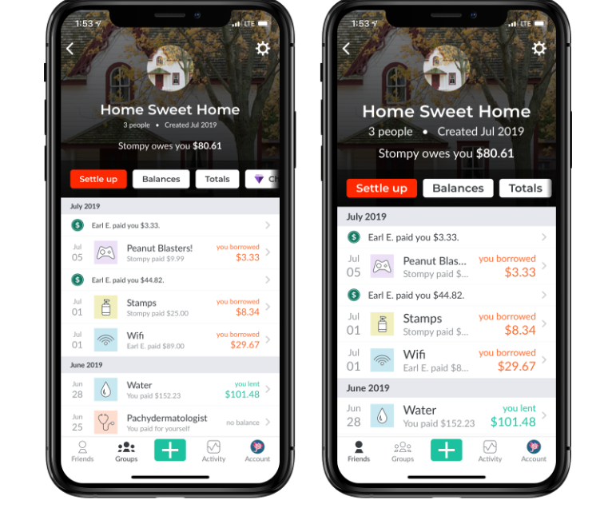

These benchmarking products represent a diverse range of AI-driven and customer-centric solutions in the restaurant industry. Each product offers unique features and functionalities to enhance customer experiences, optimize operations, and drive business growth. Evaluating these benchmarking products, including Splitwise for bill-splitting purposes, can provide valuable insights for the development and implementation of AI solutions in restaurants.

6.1 CONS FOR THE ABOVE:-

Apps like Splitwise, Venmo, Plates, and Splid offer convenient ways to split bills and manage expenses, but they also come with certain drawbacks. Firstly, these apps heavily rely on user adoption, as all parties involved need to actively use the app for seamless bill splitting. If some individuals are unwilling or hesitant to adopt the app, it can create difficulties in effectively managing expenses. Secondly, a stable internet connection is essential for the proper functioning of these apps. Poor connectivity can hinder users from accessing their accounts or completing transactions in real time.

Additionally, transaction fees may be charged for certain features or transfers, impacting the overall cost-effectiveness of using these apps. Privacy and security concerns arise as personal and financial information is shared within these platforms. Users should choose reputable apps with robust security measures in place to protect their data. Furthermore, not all merchants may accept payments through these apps, limiting their convenience for bill splitting in certain situations. Managing expenses within large groups can also be more complex with these apps, as it becomes challenging to track individual contributions accurately. Some users may find the user interface overwhelming, leading to a learning curve for new users. Lastly, the availability and quality of customer support may vary across different apps, potentially causing delays in resolving issues. Understanding these limitations can help users make informed decisions when choosing and utilizing bill-splitting apps.

In comparison to general bill-splitting apps, the Vegonomics app offers a more convenient and tailored solution. While other apps cater to various expenses, Vegonomics focuses specifically on segregating bills between vegetarian and non-vegetarian dishes. This targeted approach makes Vegonomics particularly convenient for individuals or groups with specific dietary preferences or restrictions, eliminating the need for manual calculations or discussions.

# Business Avenue

The restaurant industry has experienced a surge in business opportunities, fueled by evolving consumer preferences, technological advancements, and changing dining habits. Online food delivery platforms have unlocked new revenue streams, while virtual restaurants and ghost kitchens have reduced costs and expanded reach. Personalized customer experiences, sustainable and health-conscious options, and smart technologies have further enriched the industry. However, with the implementation of AI, these opportunities are set to soar even higher. AI brings enhanced customer insights, streamlined operations, improved personalization, advanced data analytics, cost reduction, and enhanced security. AI-powered systems can analyze customer data, automate tasks, optimize inventory management, and provide actionable insights, revolutionizing the way restaurants operate and ensuring exceptional dining experiences. The integration of AI is poised to propel the restaurant industry to new heights, driving growth, efficiency, and innovation.

# Generation of IDEA:-

The concept of Vegonomics was generated through a combination of factors, including market research, customer feedback, and a recognition of the challenges faced by both vegetarian and non-vegetarian diners when splitting bills in restaurants. The rising demand for transparency, fairness, and convenience in dining experiences catalyzed the development of a solution that specifically addressed the segregation of expenses between veg and non-veg dishes.

Extensive market research was conducted to understand the dining preferences, habits, and pain points of customers. This research revealed a significant need for an accurate and efficient method of splitting bills that catered to the diverse dietary choices of diners. Insights from customer feedback and surveys highlighted the frustration and inconvenience faced by vegetarians, vegans, and non-vegetarians when dividing expenses into group dining scenarios.

The concept of Vegonomics emerged as a way to bridge this gap and provide a user-friendly, automated solution that leverages technology, such as artificial intelligence and image recognition, to identify and segregate veg and non-veg dishes on the bill accurately. By developing a dedicated app or software, Vegonomics aims to simplify the bill-splitting process, promote fairness, and enhance the overall dining experience for all parties involved.

The concept was further refined through collaboration with industry experts, restaurant owners, and potential end-users. Their valuable insights and feedback helped shape Vegonomics into a practical and innovative solution that addresses the specific challenges of splitting veg and non-veg bills in restaurants.

Overall, Vegonomics was generated by recognizing the need for a specialized tool in the restaurant industry that caters to the growing demand for transparency, fairness, and ease of bill splitting between vegetarian and non-vegetarian diners, with the ultimate goal of improving the dining experience for all.

# Conceptual Elaboration

The main aim of ideation for Vegonomics involved a systematic approach to transforming the idea into a viable and practical solution. Here are the key steps taken in the concept development process:

1. Ideation: The initial stage involved brainstorming and ideation sessions to explore the concept of splitting veg and non-veg bills in restaurants. The focus was on identifying pain points, understanding customer needs, and envisioning a solution that would address these challenges effectively.

2. Market Research: Extensive market research was conducted to gather insights into dining preferences, customer behaviours, and existing solutions for bill splitting. This research helped identify gaps in the market and understand the competitive landscape.

3. Customer Feedback: Feedback from potential users, including both vegetarian and non-vegetarian diners, was collected through surveys, interviews, and focus groups. This feedback provided valuable insights into their experiences, pain points, and expectations related to bill splitting in restaurants.

4. Technological Feasibility: The concept's technological feasibility was evaluated by assessing available technologies, such as artificial intelligence, image recognition, and mobile applications. The research was conducted to determine if these technologies could accurately identify and segregate veg and non-veg dishes on a bill.

5. Collaboration: Collaboration with industry experts, restaurant owners, and relevant stakeholders played a vital role in concept development. Their expertise and feedback helped refine the concept, validate assumptions, and ensure practicality and relevance to the restaurant industry.

6. Prototype Development: A functional prototype of the Vegonomics solution was developed to demonstrate its core functionalities and user interface. This prototype was used for testing, feedback gathering, and further refinement.

7. Iterative Design: The concept went through multiple iterations, incorporating feedback and making improvements based on user testing, market research insights, and technological advancements. The goal was to create a user-friendly, efficient, and accurate solution that met the needs of both customers and restaurants.

8. Business Viability Assessment: A comprehensive assessment of the concept's business viability was conducted, considering factors such as market size, potential target customers, revenue streams, cost structure, and scalability. This assessment helped validate the concept's potential for success and identify potential challenges and mitigating strategies.

9. Go-to-Market Strategy: A go-to-market strategy was developed, outlining the steps to launch and promote Vegonomics in the restaurant industry. This strategy included marketing plans, partnership opportunities with restaurants and technology providers, and a roadmap for product rollout and expansion.

This process for Vegonomics aimed to create a practical, innovative, and user-centric solution that addressed the challenges of splitting veg and non-veg bills in restaurants. Through a combination of market research, customer feedback, collaboration, iterative design, and business viability assessment, Vegonomics evolved into a concept ready for implementation and integration into the restaurant industry.

# Final AI service prototype

The service of AI will be carried out as follows:-

The AI prototype for Vegonomics would be a mobile application with an intuitive user interface. Here's a description of its key features and functionalities:

1. User Registration: Users can create accounts and set up their profiles within the app. They can provide their dietary preferences (vegetarian, non-vegetarian, vegan, etc.) to ensure accurate bill splitting.

2. Image Recognition: The app utilizes AI-powered image recognition technology to scan and analyze the restaurant bill. Users can simply take a photo of the bill using their smartphone camera within the app.

3. Dish Segregation: The AI algorithm processes the image and identifies the veg and non-veg dishes listed on the bill. It separates them into respective categories, ensuring accurate segregation.

4. Item Verification: The app provides a list of identified dishes, allowing users to review and verify the accuracy. Users can make corrections if any items are misclassified.

5. Cost Calculation: Once the dishes are segregated, the app calculates the individual costs for veg and non-veg items, respectively, based on the menu prices provided.

6. Splitting Options: Users can choose from different splitting options, such as an equal split among all diners, splitting by specific dishes, or customizing the distribution of costs based on individual preferences.

7. Payment Integration: The app may include payment integration, allowing users to make payments directly within the app. This feature simplifies the process of settling the bill after splitting.

8. Bill Summary and Sharing: The app generates a detailed summary of the split bill, indicating the costs for each category and individual diner. Users can easily share the bill summary with their fellow diners via messaging apps or email.

9. User Profiles and History: The app maintains user profiles and keeps a record of past bills, providing a convenient reference for future dining experiences.

10. Feedback and Rating: Users can provide feedback and ratings for the restaurant, dish accuracy, and overall experience, helping to improve the app's performance and enhance future user interactions.

Please note that this is a high-level description of the AI prototype, and the actual design and implementation may vary based on specific technical considerations and user requirements.

This is just an indecisive visual representation of the app.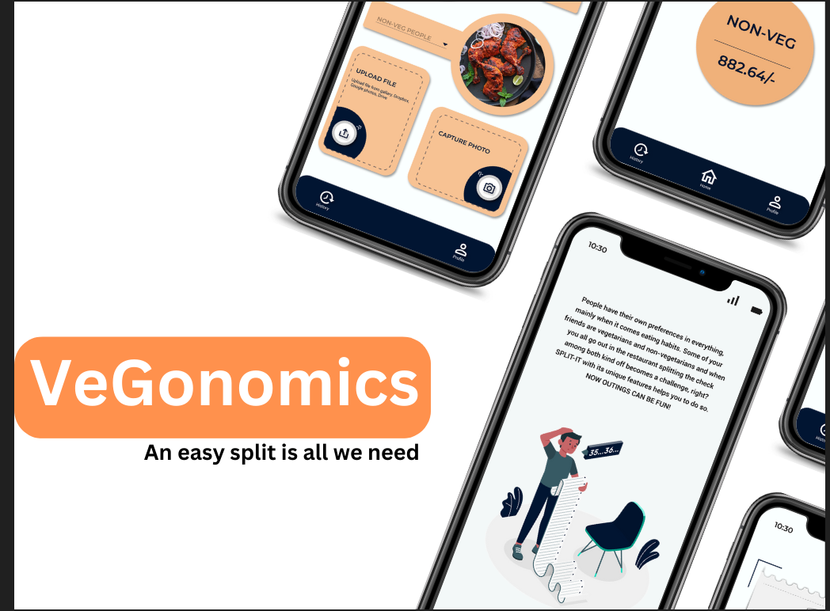

# Tech-STACK:

The Vegonomics app requires the development of a mobile application to provide a user-friendly interface for customers. This mobile app can be built using frameworks like React Native or Flutter, allowing for the development of a single codebase that can be deployed on both iOS and Android platforms. These frameworks enable efficient cross-platform development, saving time and effort in creating separate apps for different operating systems.

A crucial aspect of the app is the user interface (UI) design, which plays a significant role in providing a seamless and visually appealing experience. Design tools such as Sketch or Figma can be employed to create the UI designs, ensuring an intuitive and engaging interface that aligns with the app's branding and usability goals.

On the backend side, a robust server-side logic is required to handle data processing, calculations, and integration with external systems. Backend frameworks like Node.js or Django can be utilized to build the server-side components, enabling efficient handling of data flow, business logic, and communication with databases and APIs.

To store and manage data related to customers, menu items, and orders, a database management system is necessary. Depending on the specific requirements, options like PostgreSQL, MySQL, or MongoDB can be considered for efficient data storage and retrieval. These database systems provide reliable and scalable solutions to manage and organize the app's data effectively.

The AI capabilities of the Vegonomics app rely on machine learning algorithms to categorize veg and non-veg dishes accurately and perform the necessary calculations for bill splitting. Machine learning frameworks such as TensorFlow or PyTorch can be employed to develop and train the models responsible for these AI functionalities. These frameworks offer a wide range of tools and resources to build and deploy machine learning models efficiently.

To integrate with external systems such as POS systems, online payment gateways, or other third-party services, the development of robust APIs is required. RESTful APIs can be developed to facilitate seamless communication and data exchange between the Vegonomics app and the external services it interacts with. These APIs allow for smooth integration and enable the app to leverage the functionalities and services provided by external platforms.

For efficient deployment, scalability, and easy maintenance, leveraging cloud infrastructure is recommended. Cloud platforms like Amazon Web Services (AWS) or Google Cloud Platform (GCP) provide a range of services and resources to host and manage the Vegonomics app. These cloud platforms offer scalability, high availability, and reliable infrastructure to handle user traffic and data storage needs effectively.

Lastly, integrating popular payment gateways such as PayPal, Stripe, or Braintree is essential to handle secure and seamless online payments within the Vegonomics app. These payment gateway integrations ensure that customers can securely make transactions, providing a smooth and trusted payment experience.

These recommendations serve as a starting point and can be adjusted as needed to best suit the development and deployment of the Vegonomics app.

# Revenue model:

To implement a payment model where the Vegonomics app is paid for by the restaurants and free for users, we can consider the following approach:

1. Revenue from Restaurants: The primary source of revenue would come from charging restaurants a subscription fee or a transaction fee for using the Vegonomics app. Restaurants can pay a monthly or yearly subscription fee to access and utilize the app's bill-splitting and financial modelling functionalities. Alternatively, a transaction fee can be charged for each bill split using the app.

2. Value-Added Services: Offer additional value-added services to restaurants for an additional cost. This could include advanced analytics and reporting features, integration with their existing POS systems or accounting software, custom branding options, or dedicated customer support. These optional services can provide enhanced value to restaurants, and they can choose to subscribe to them based on their specific needs.

3. Freemium Model for Users: The Vegonomics app can be made available to users for free, enabling them to benefit from the convenience of bill splitting between veg and non-veg items. The core features of the app, such as item categorization, bill calculations, and personalized bill summaries, would be accessible to users without any charge.

4. In-App Advertisements or Partnerships: To generate additional revenue, the app can incorporate in-app advertisements or partnerships with relevant brands or restaurants. This can include displaying targeted advertisements to users based on their dining preferences or partnering with restaurants to promote their offerings within the app. These advertising or partnership opportunities can provide a source of income without directly charging users.

5. Data Monetization: The app can leverage anonymized and aggregated data to generate insights and trends in the restaurant industry. This data can be valuable to market researchers, food distributors, or other industry stakeholders. By ensuring proper data privacy and obtaining user consent, the app can explore partnerships or data monetization strategies to generate revenue from the insights derived from the data collected within the app.

It's important to strike a balance between providing value to restaurants through the paid model and ensuring a free and user-friendly experience for app users. Offering a compelling set of features and benefits to restaurants will incentivize their adoption and willingness to pay while keeping the app free for users encouraging wider usage and adoption of the Vegonomics app within the dining community.

**13.** APPROACH:-

1. **Data Preparation:**

- Collect a dataset containing dish names, prices, and their corresponding labels (veg or non-veg).

- Then pre-process the data in such a way that the class for nonveg will be ‘1’ and for veg, it will be ‘0’.

- Read the dataset into a pandas Data Frame, extracting the 'NAMES' and 'PRICE' columns as features (X) and the 'CLASS' column as the target variable (y).

2. **Machine Learning Model Training:**

- Choose a suitable machine learning algorithm for classification, such as a Random Forest Classifier.

- Instantiate the model with desired hyperparameters, such as the number of estimators.

- Fit the model using the feature matrix (X) and target variable (y) to train the classifier.

3. **Input Dish Details from the User:**

- Prompt the user to enter the name and price of each dish, allowing them to input multiple dishes.

- Store the dish names and prices in a list.

4. **Bill Split Calculation:**

- Initialize variables for the veg and non-veg subtotals as 0.

- Iterate through each dish in the list of new dishes.

- For each dish, predict its veg/non-veg category using the trained machine learning model.

- Update the veg or non-veg subtotal accordingly based on the prediction.

5. **Share Calculation and Output:**

- Prompt the user to enter the total bill amount and the number of diners.

- Calculate the share per person for veg and non-veg items by dividing the respective subtotals by the number of diners.

- Calculate the total bill per person by dividing the total bill amount by the number of diners.

- Display the total bill, veg, and non-veg subtotals, veg and non-veg share per person, and total per person.

The algorithm leverages a machine learning model to predict the veg/non-veg category of each dish based on its name and price. It then performs the bill split calculation, considering the user's input for the total bill amount and the number of diners. Finally, it outputs the calculated values for the bill split and shares per person.

Note that the accuracy and effectiveness of the bill split and category prediction depend on the quality and coverage of the training data, the choice of the machine learning algorithm, and the user's input accuracy.

**LINK TO THE BASIC IMPLEMENTATION OF THE VEGONOMICS APP WITH PERSONAL DATASET.**

**-**[**https://drive.google.com/drive/folders/1VHZtjbBL6vnONKd2yTu5EzyR0mx-Zk_X?usp=drive_link**](https://drive.google.com/drive/folders/1VHZtjbBL6vnONKd2yTu5EzyR0mx-Zk_X?usp=drive_link)

# 

# 14. References

* https://punchh.com/blog/2021/07/28/the-use-of-artificial-intelligence-in-the-restaurant-industry-impact-and-benefits/
* https://www.gotenzo.com/resources/insight/artificial-intelligence-and-restaurants-a-recipe-for-success/
* https://bloomintelligence.com/blog/artificial-intelligence-restaurant-industry/
* <https://www.entrepreneur.com/en-ae/technology/embracing-artificial-intelligence-in-the-food-industry-how/451146>

**15.** Conclusion:-

In conclusion, Vegonomics is an innovative app that utilizes machine learning to facilitate the splitting of bills in restaurants between vegetarian and non-vegetarian dishes. By leveraging advanced technologies, Vegonomics streamlines the bill settlement process, ensuring fairness and convenience for both veg and non-veg diners. Through the integration of a machine learning model, Vegonomics categorizes dishes as veg or non-veg based on their names and prices. This classification enables the app to accurately calculate the subtotals for each category, allowing for a precise division of expenses among diners.

Vegonomics offers a user-friendly interface where individuals can input the dish details, such as names and prices, and receive an instant breakdown of the bill. Additionally, the app takes into account the total bill amount and the number of diners to compute the share per person, making the bill-splitting process seamless and efficient. The implementation of Vegonomics not only simplifies the process of dividing bills in restaurants but also promotes transparency and flexibility. It eliminates the need for manual calculations and minimizes potential errors, ensuring that each diner pays their fair share accurately.

With its intelligent algorithm and user-centric design, Vegonomics sets itself apart as a practical and convenient solution for group dining experiences. By providing clear and individualized bill breakdowns for veg and non-veg items, Vegonomics enhances customer satisfaction and reduces potential conflicts arising from bill settlements.

In summary, Vegonomics represents a significant advancement in the restaurant industry, harnessing the power of machine learning to optimize the bill-splitting process. Its ability to accurately categorize and allocate expenses between veg and non-veg dishes offers a modern, efficient, and fair approach to dining expenses, making it a valuable tool for both diners and establishments alike.